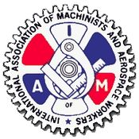

To LL1681 Members
AVEOS
July 16, 2011

Re: Aveos Negotiations

LL1681 will be holding an election for the position of Aveos Negots rep for the upcoming round of negotiations with Aveos. Any member interested in running for this position should contact me as soon as possible either by email (granthornsby@shaw.ca) or by phone 780 977 4831.

Please remember that you must be listed on the Aveos seniority list to hold this position.
In solidarity
Grant Hornsby
LL1681 President

